**Unveiling the Mysteries of Quantum Computing**

By Amitesh | Published on December 8, 2024

**How Does Quantum Computing Work?**

Quantum computing represents a revolutionary leap in computational capabilities. Unlike traditional computers, which use bits as the smallest unit of data, quantum computers leverage quantum bits, or qubits. These qubits can exist in multiple states simultaneously, thanks to the principles of superposition and entanglement.

Imagine solving complex problems in seconds that would take classical computers millions of years. This potential positions quantum computing as a game-changer for industries like cryptography, materials science, and artificial intelligence.

An example of a quantum computer prototype. (Image: AI Genrated )

**How Does Quantum Computing Work?**

At the heart of quantum computing lies quantum mechanics. The ability of qubits to exist in a state of superposition means they can perform multiple calculations at once. Moreover, qubits can be entangled, allowing for an intricate web of interdependent calculations that dramatically enhance processing power.

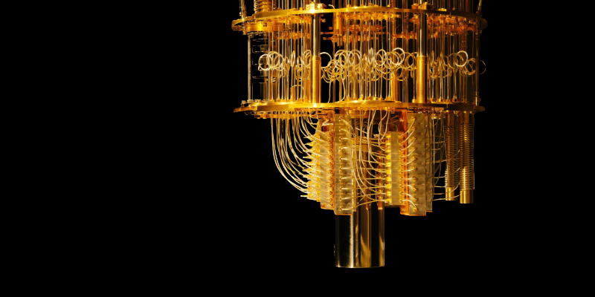An example of a quantum computer prototype. (Image Credit: IBM)

**Applications and Future Impacts**

Quantum computing promises transformative impacts in numerous fields:

* **Cryptography:** Breaking encryption methods currently deemed secure.
* **Medicine:** Designing new drugs and understanding protein structures faster than ever.
* **Logistics:** Optimizing supply chains and reducing inefficiencies.

As research progresses, companies and governments are heavily investing in quantum technologies, signaling the start of a new computational era.